
CSE4097 - Engineering Project I
Analysis and Design Document
USING HIERARCHIES IN REINFORCEMENT
LEARNING FRAMEWORK WITH
NON-STATIONARY ENVIRONMENTS
Group Members
Ezdin ASLANCI 150112022
Ahmet Kutalmış COŞKUN 150113018
Project Advisor
Assoc. Professor M. Borahan TÜMER

- Introduction
asdasd
  - Problem Description and Motivation
asdasd
  - Scope of the Project
  - Definitions, Acronyms, and Abbreviations
- Related Work
- System Design
  - System Model
Environmental changes should be detected as the agent learns and the learning process must be intervened according to magnitude and structure of environmental changes. In this context, the learning of the agent and the detection of changes in non-stationary environments can be expressed as a client-server connection. On the client side, while learning is being done by the agent, at certain time intervals, server(SCD) will response that whether the environment has changed, and if so, how the new learning process should continue.
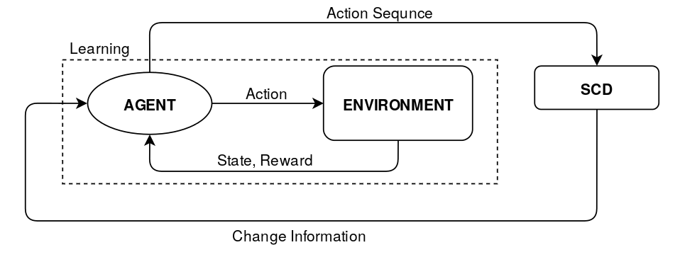
As seen in the communication diagram above, the changes will be detected by observing the actions of the agent because if the environment changes, the reward values which are response of the environment to actions of the agent will also change. After SCD observes action sequence, it will inform to agent about current state of the environment and here is the response messages:
- No change in the environment, continue learning.
- Change has been detected ! An environment you have not encountered before, relearn !
- Change has been detected! Model of this environment exists in your memory, continue with this model.
- Change has been detected! Only a certain part of the environment has changed, just to relearn that part.
  - Flowchart and/or Pseudo Code of Proposed Algorithms
As mentioned above, our project is about communication between the two main processes. In first process, agent learns the environment with RL algorithms wihich are Qlearning, PS and HRL and listens response messages from second process. If any change detected in environment either new model will be created or a model from memory will be loaded. In both cases, old model will be sent to the memory.
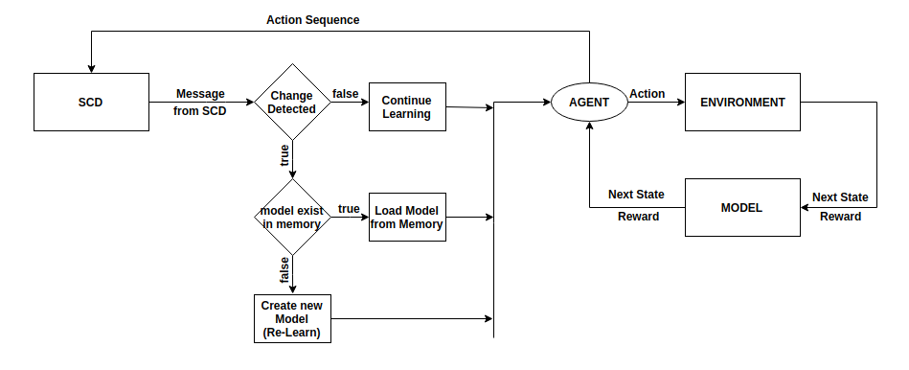
In serve side, detection process will wait until message from the learning process. When the server receives the message, it will take action sequence from the agent and send to agent information that wheter environment is changed or not according to analysing the action sequence in SCD process.
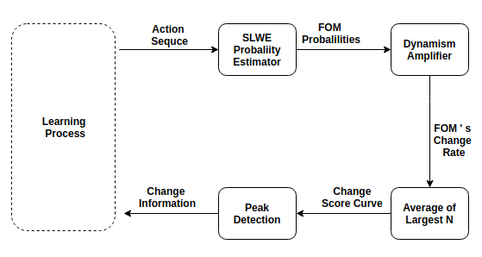

Algorithm: SLWE Change Detection
Repeat N times while PQueue is not empty
(s, a) = pop from PQueue
(s', r) = Model_{c}(s, a)
Q_{c}(s, a) = Q_{c}(s, a) + φ[r + γ^{k}max_{a'}Q_{c}(s', a') - Q_{c}(s, a)]
Repeat for all s'', a'' predicted to lead to s
r'' = predicted reward from Model
p = r'' + γ^{k}max_{a'}Q_{c}(s, a) – Q_{c}(s'', a'')
if p > Ө
push (s'', a'') into PQueue with priority p
If end of the episode
Search sub-goals with Betweenness Centrality
If Variance of Sub-goal counts < 1
Create options
Learn options

In SCD process, there are four main modules with their pseudo codes except SLWE Probability Estimator and explanation of this module will not be in this document because it is in improvement and publishing process. Detailed algorithms and explanations about SLWE Probability Estimator will be ready in the thesis book.

  - Comparison Metrics
There are few metrics being used for measuring the learning performance of Reinforcement Learning algorithms. Specifically, on the grid world problem, the agent’s objective is to reach the goal state with the minimum number of steps. This makes the number of steps a good concept for tracking convergence and divergence of learning process. We expect to get instant jumps on the step count curve after the current behavior of environment changes.
Moreover, we are planning to use the sequence of actions as an input to the change point detection algorithm we developed. The change points we get from the algorithm will be compared with the true change points we expect to get. We know these true change points because while conducting experiments, we will determine the points where the current behavior of the environment changes. We are planning to use Standard Accuracy Criteria (SAC) for measuring the success of behavior change detection.
 | Change Present | Change Absent | Total
Change Detected | a | b | a+b
Change not Detected | c | d | c+d
Total | a+c | b+d | a+b+c+d

Measure Name | Definition | Ideal Value
Sensitivity |  | 1
Specificity |  | 1
False Negative Rate |  | 0
False Positive Rate |  | 0
Predictive Value Positive (PVP) |  | 1
Predictive Value Negative (PVN) |  | 1
False Alarm Rate |  | 0
False Reassurance |  | 0

  - Data Sets or Benchmarks
The current version of project is an offline system and it is not end to end system. So, we get data from RL train and we know time where the environment is changed. We change the environment several times while agent learns and agent does not know that the environment has changed. When the agent complete training we get action sequence of agent that the agent perform during the traning time.
Our data, action sequnce is one dimensional data which is compination of four elements; left, right, down and up. According to grid size and RL parameters our data size is changed. For example; when we increase grid size linearly our data size is also increase as exponantionaly. The other factors which affects data size are parameters and one of the most important parameters is epsilon because epsilon affects data size directly. Epsilon is probability of non-gredy action selection and it is beween 0 to 1. When we decrease epsilon traing time takes longer.
As mentioned above, our data is one dimensional and combination of 4 elements. We know where we have change points, where the environment changed. We analyse data with SCD process and our expectations is finding true change points.
- System Architecture
- Experimental Study
- Tasks Accomplished
  - Current State of the Project
To explain current state of the project, we should take our project as sub-project; Reinforcement Learning and Change Detection.
In Reinforcement Learning side, we have implemented two basic learning algorithm; Prioritized Sweeping and Q-Learning. Our software that we designed on Python for learning part of project supports multi environment trainig and also our software has betweenness centrality calculator tool and all our implementations generic and we will not encounter problems while we implement Hirarchial Reinforcement Learning. We have some other language implementations for learning to be able to get data much more faster without GUI.
In Change Detection side, we have finished SCD implementation on Matlab and it can set of experiments but our expectation is that SCD shoud be as fast as possible. Response time of SCD is not acceptable for an online system. So we re-implement SCD on C++ but SCD C++ implementation can not run set of experiments. We can do our experiment on C++ manualy.
  - Task Log
During this semester, we have meeting wiht our advisor each weak on Monday. In these meetings, we reported our weakly progress and we made a brainstrom about existing and possible problems with our advisor.
We compared and analyzed the results of satisfactory and non-satisfactory tests. We have done risk analysis against possible problems, for example if the data is too large or the SCD is weak against small changes.
Until now, we have observed acceptable experimental results with different parameters in different environments which are approved by advisor.
  - Task Plan with Milestones
The most important task that should be completed immediately is finishing improvement and publishing SCD C++ implementation. We have some real world industrial data and we will publish our SCD algorithm after we get expected results from industial data before second semester.
HRL impementation is aso very important task for improving our project because for QLearning and PS algorithms we can not run experiments in large environments. When we implement HRL, we will be able to run exmeriments on more than 100x100 grids. Secon task about HRL is HRL-CD implementation. We want to re-imlement HRL-CD which is written by Yücesoy and Tumer and novelty is appling HRL-CD ball catching problem instaed of grid world problem.
As mentioned in current state of project, we can manualy run our experiments. So our other task to complete is improving SCD and new version will be able to run set of experiments automatically. Our another task about SCD was writing muti-thread support version but speed of SCD is enough for online system, so we remove this task from our list.
The main goal of the project is making online end to end system which detects changes while agent learns and SCD will send information about changes and agent will update learning strategies according to this informations. After we build end to end sytem, we will test our results and if they are not satisfied we resort to new methods.
- References

